<https://liderlamp.es/>

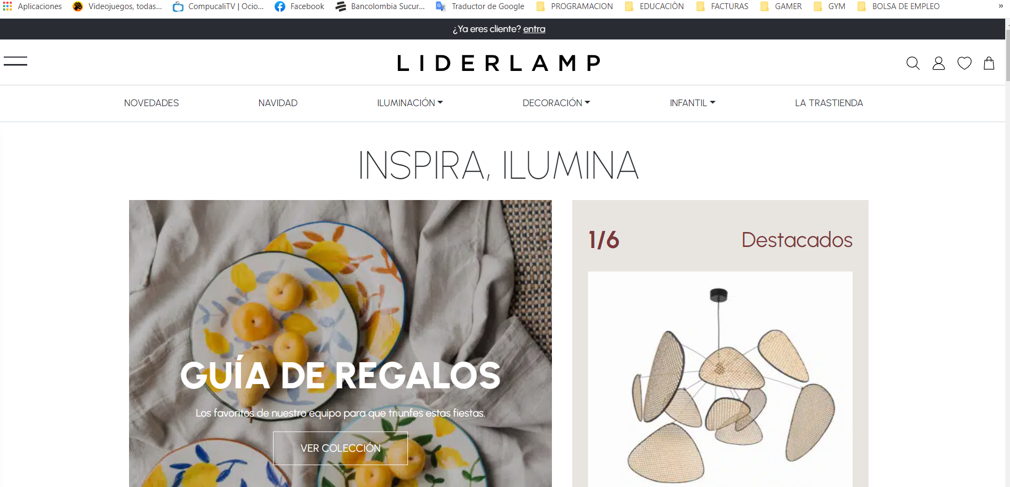

<https://www.bershka.com/es/h-woman.html?_ga=2.207950807.415656972.1672063244-2020962093.1668624125>

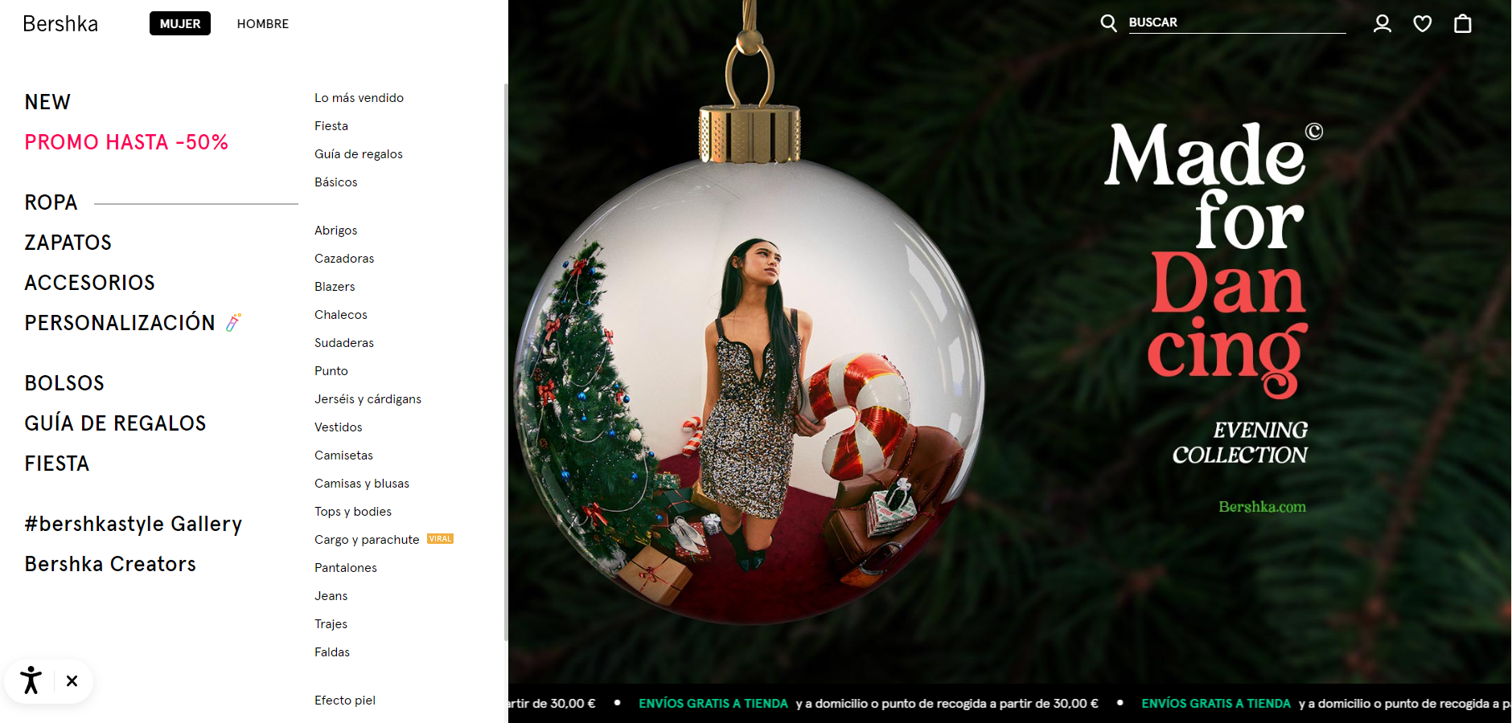

<https://www.amazon.es/>

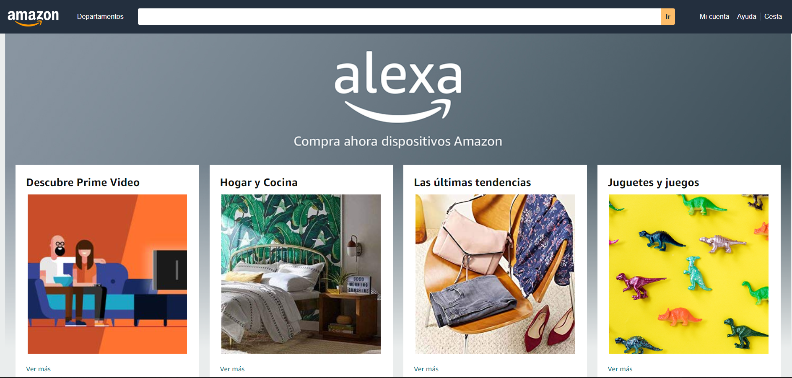

<https://bitetoothpastebits.com/>

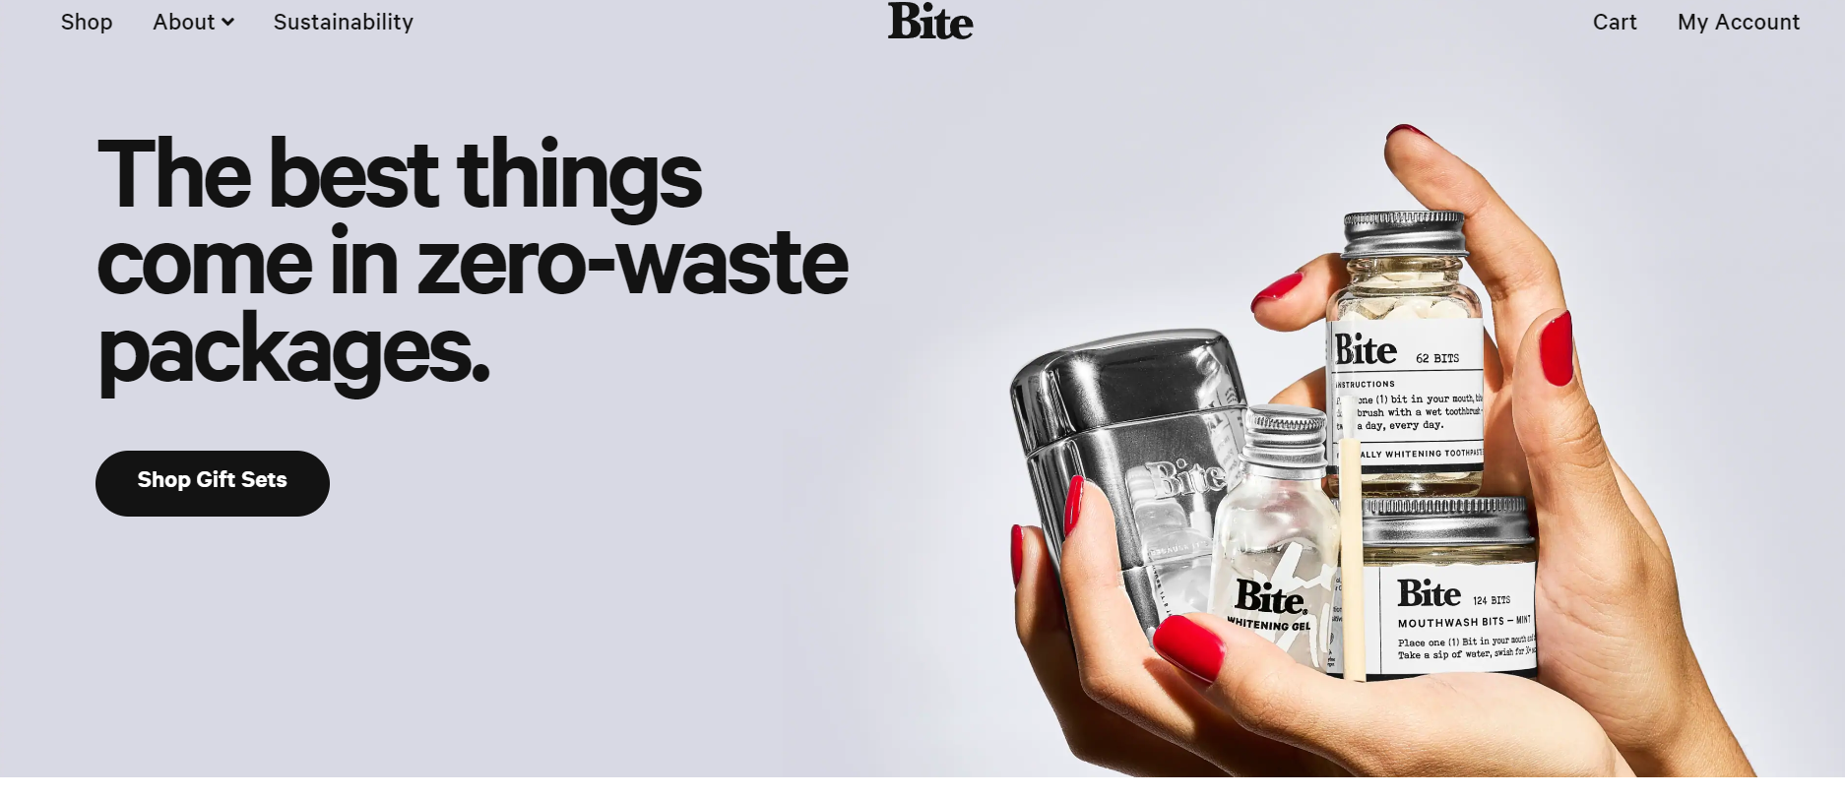

<https://simplychocolatecph.com/>

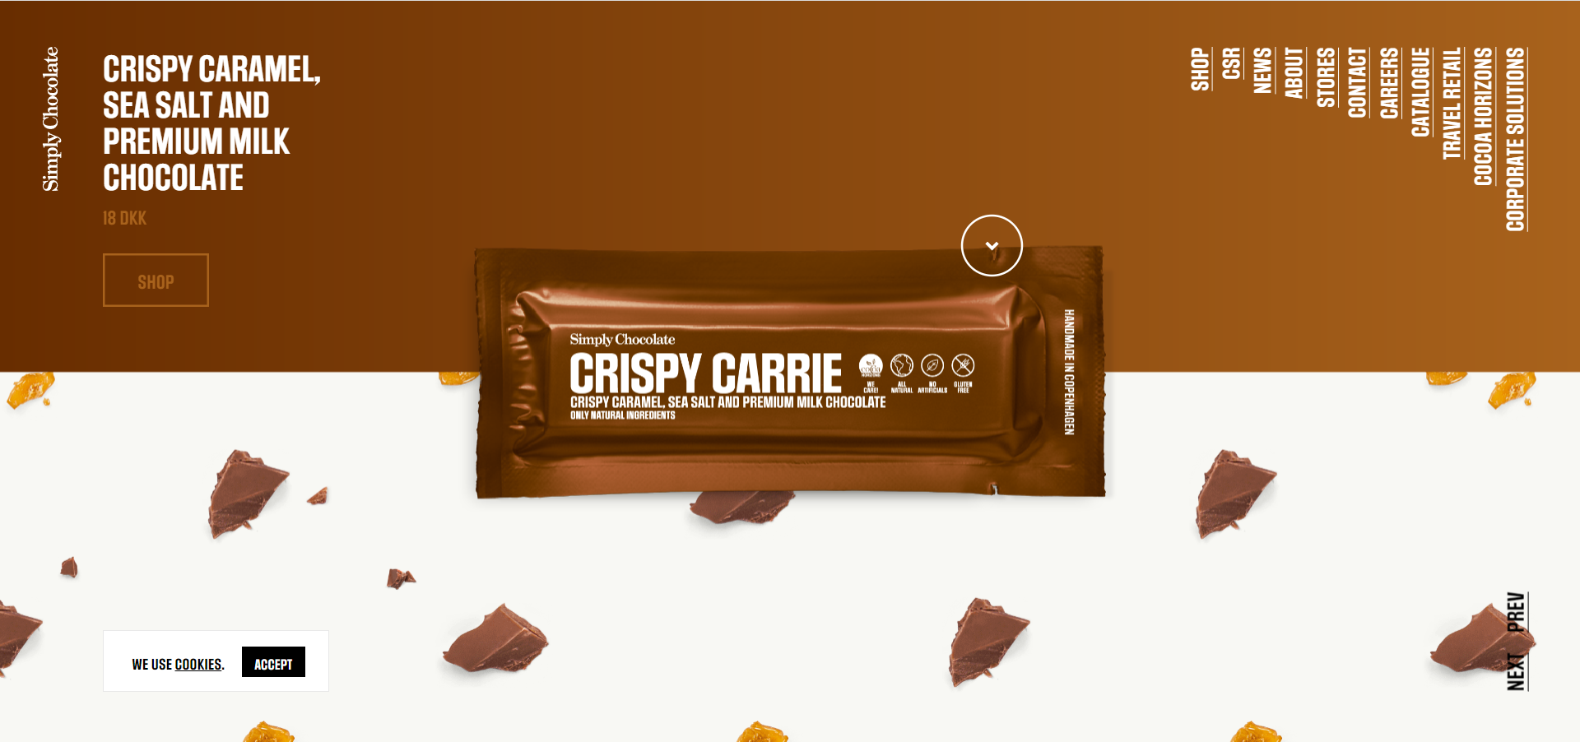

<https://www.protest.eu/>

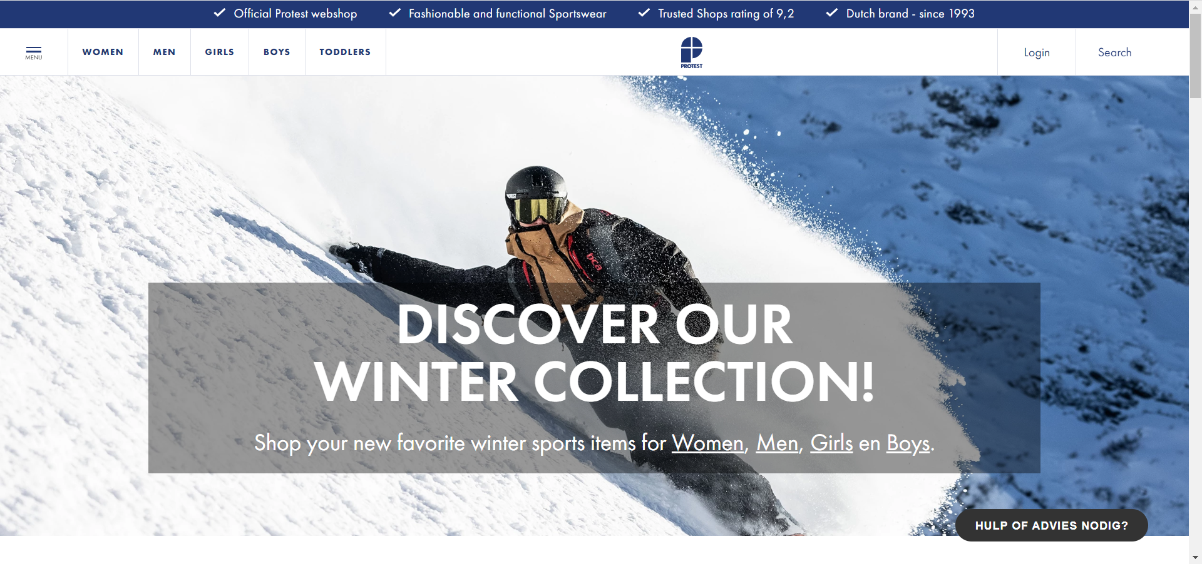

<https://smokehaus.com.au/>

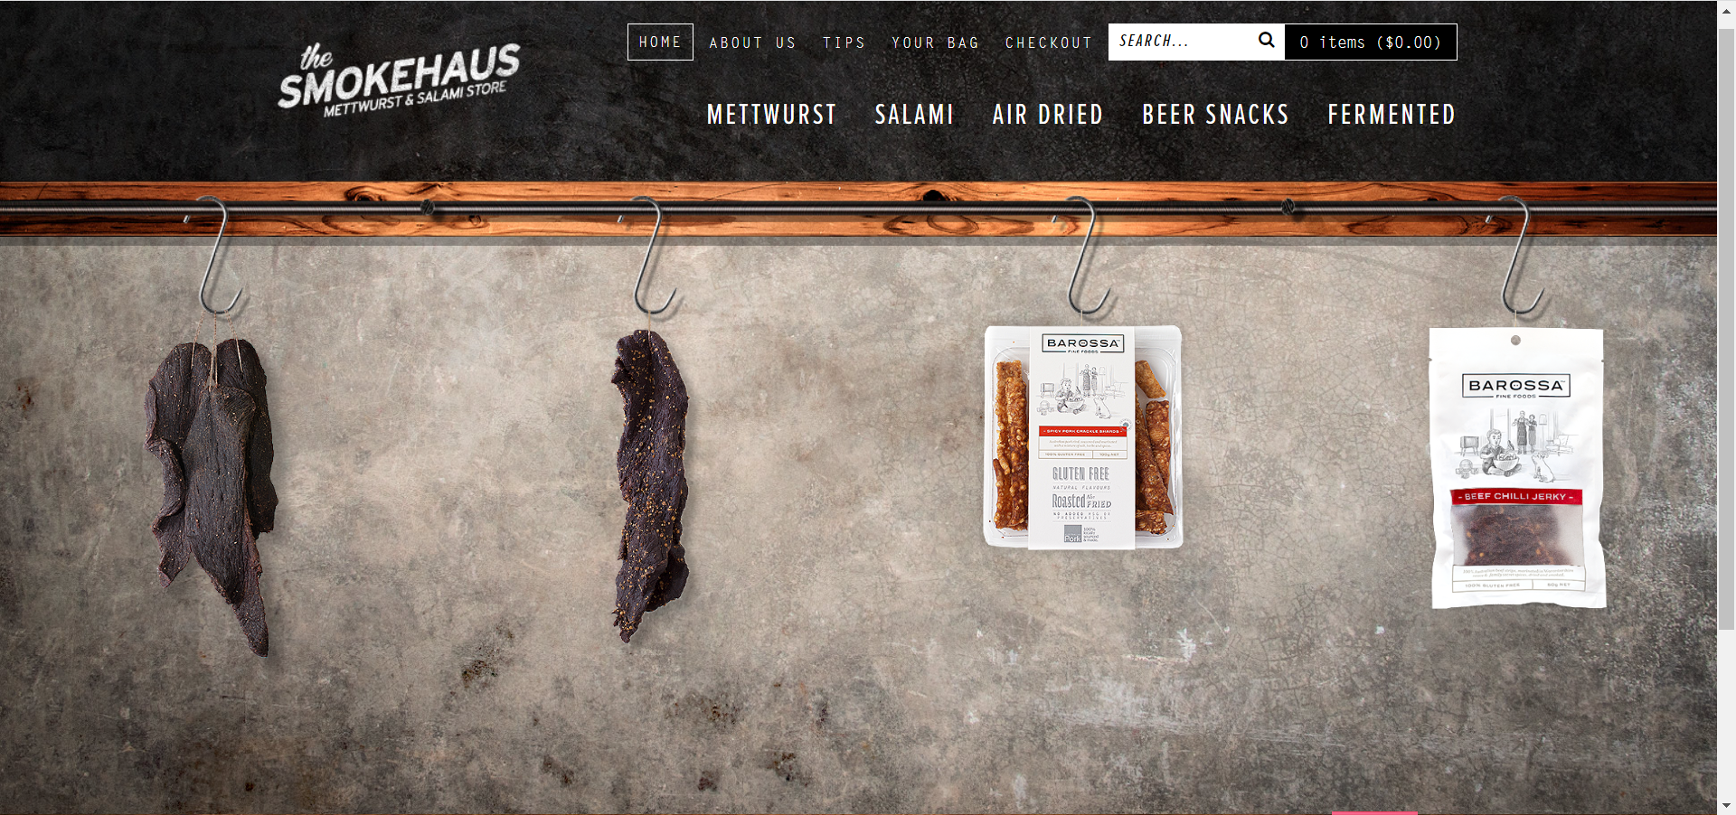

<https://www.allbirds.com/>

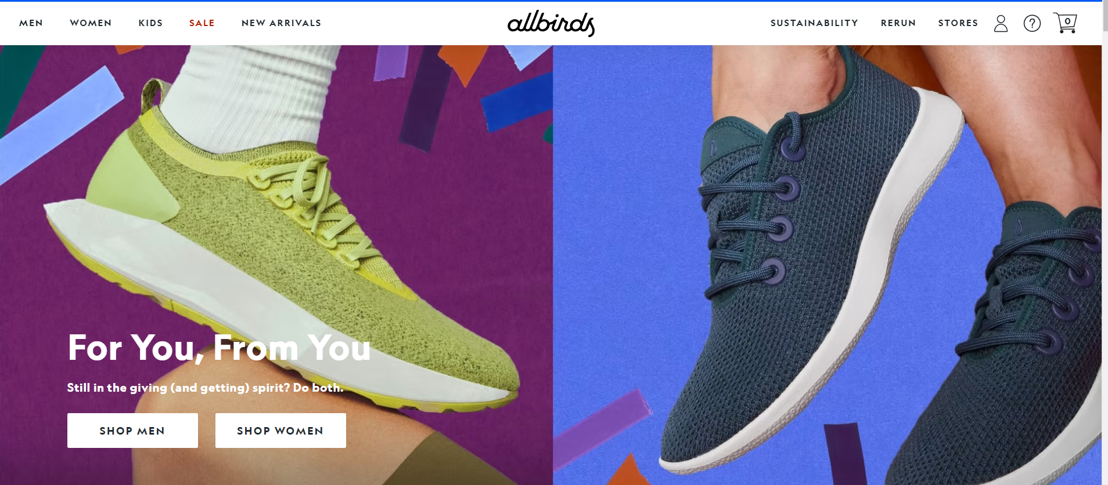

<https://www.fabletics.com/index.cfm?gender=M&first_visit=1>

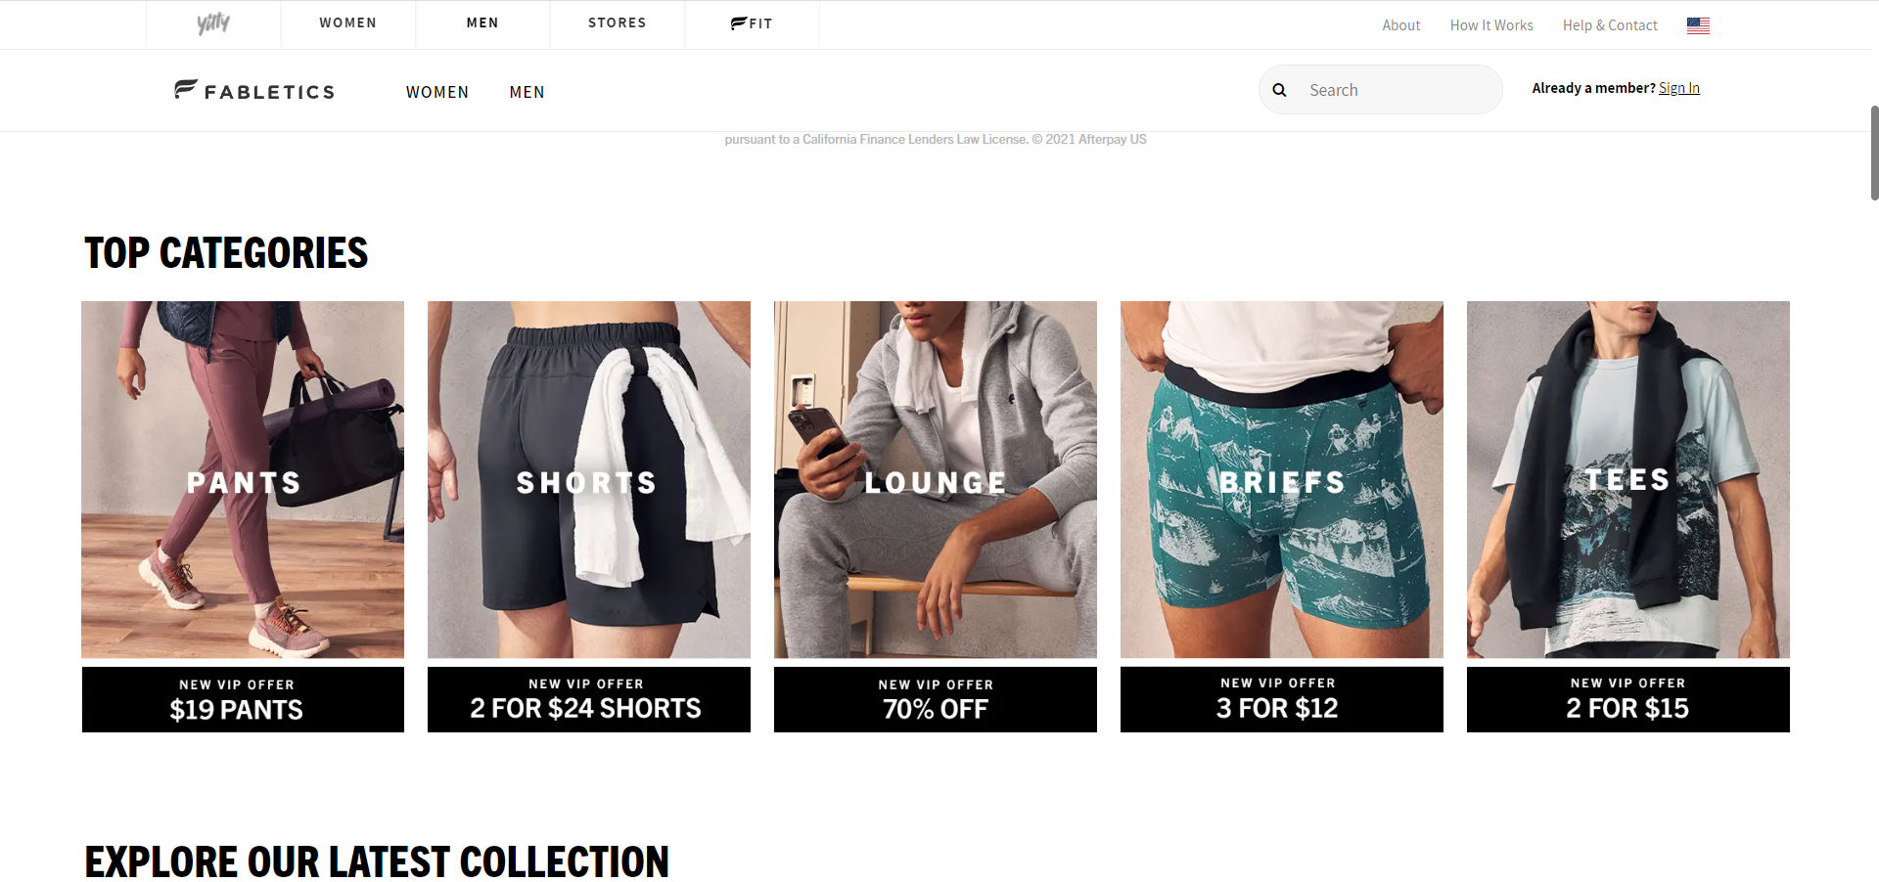

<https://www.forever21.com/>

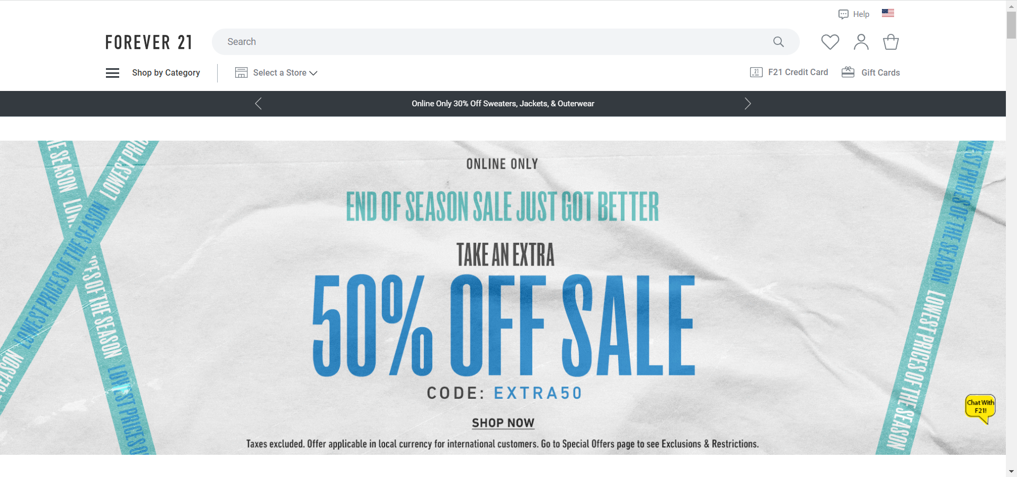

<https://notebooktherapy.com/>

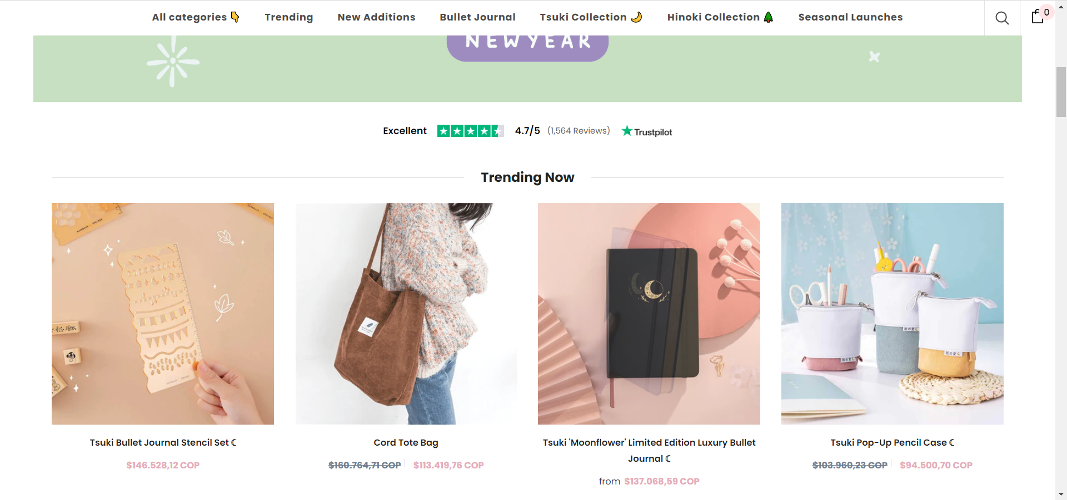

<https://girlfriend.com/>

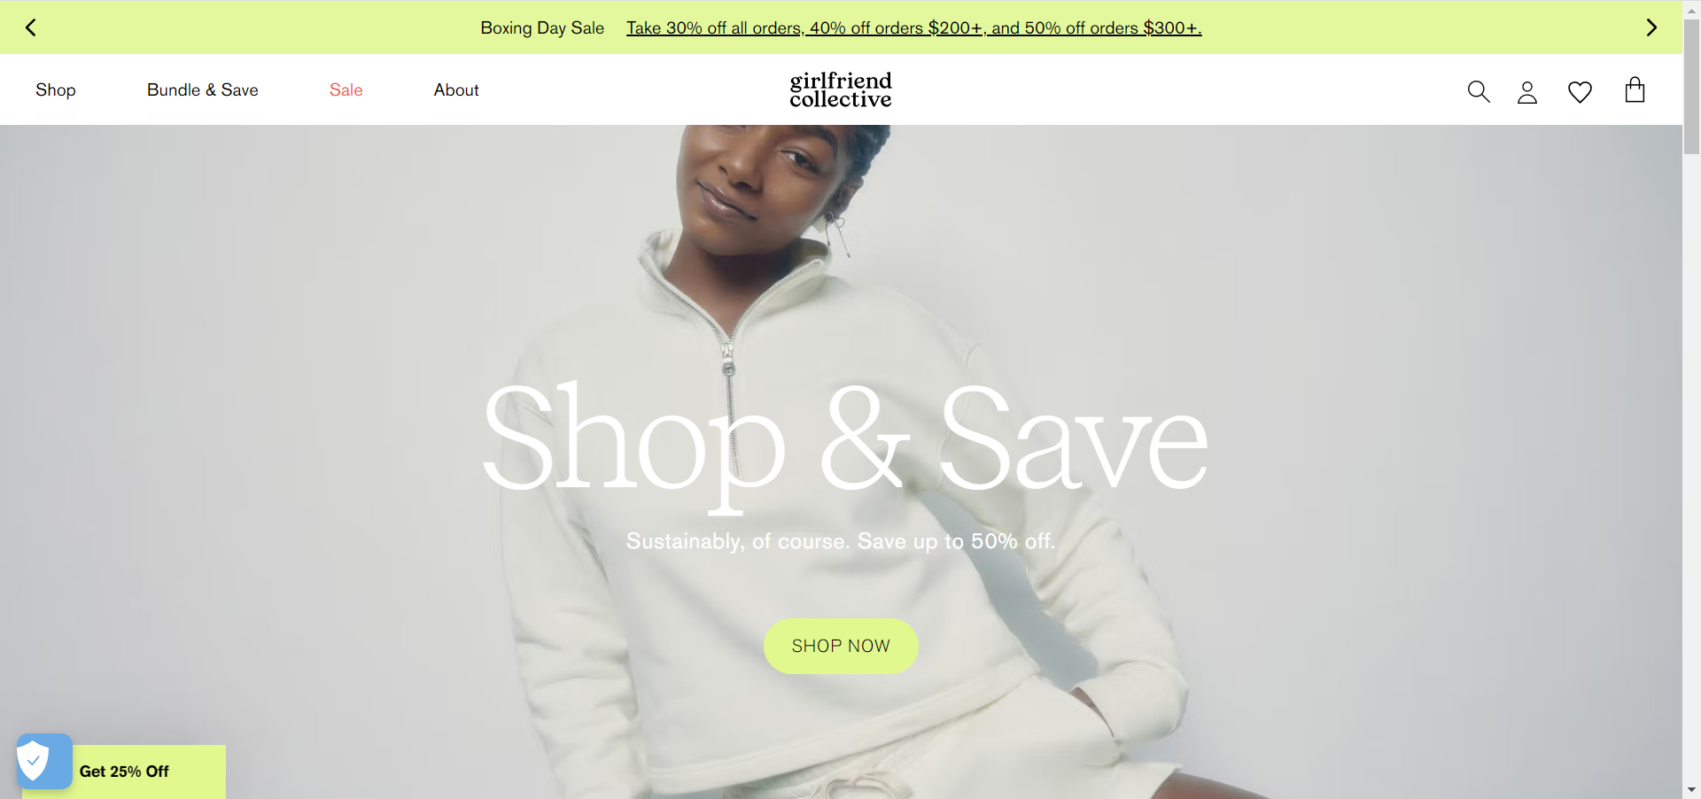

<https://vauni.com/>

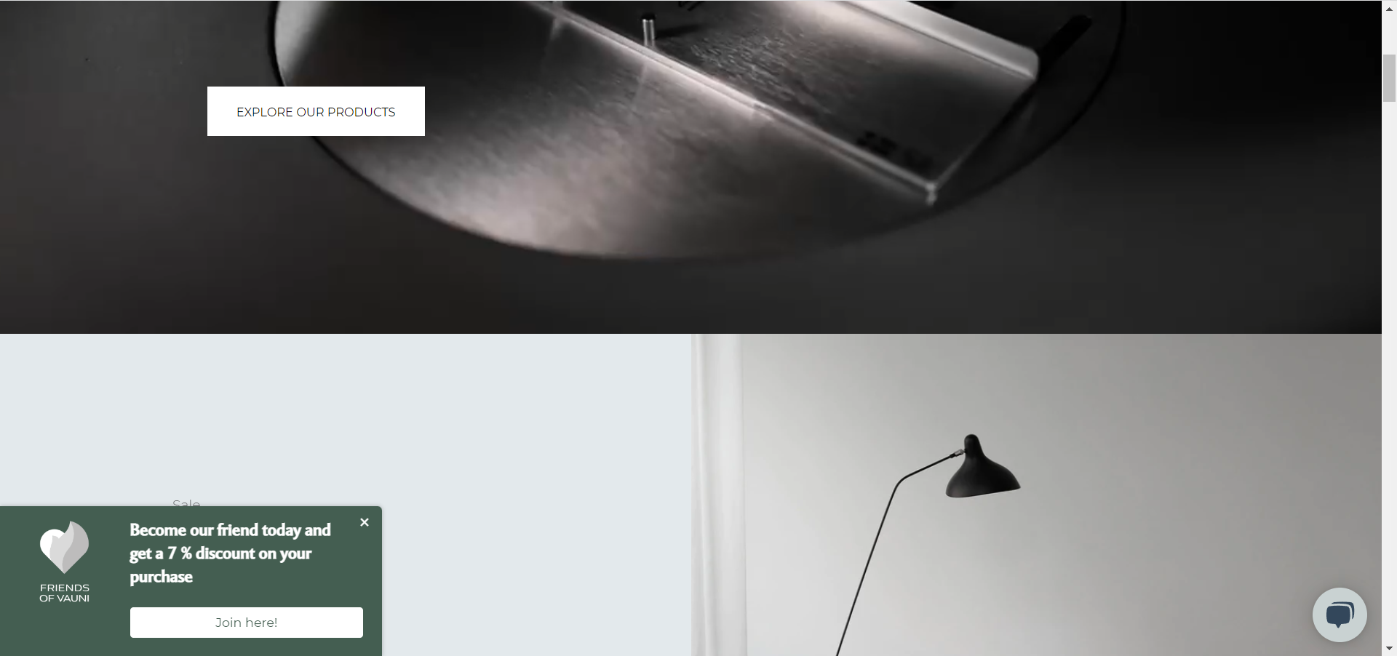

<https://wanderlustlife.co.uk/>

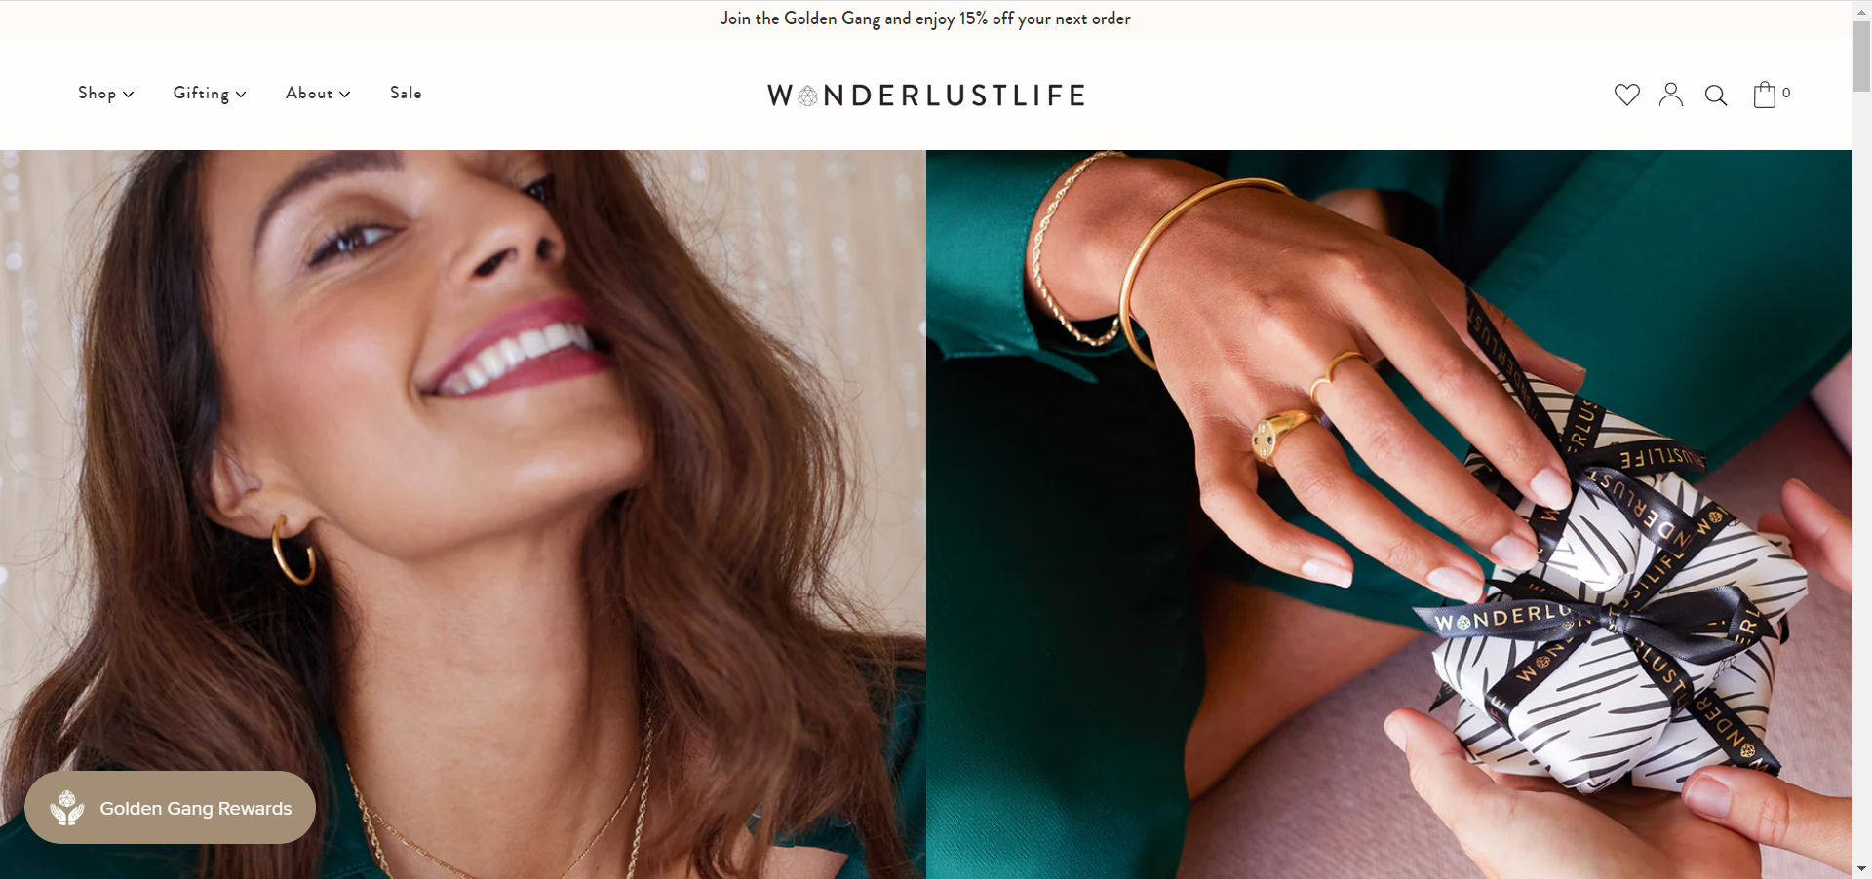

<https://caliroots.com/>

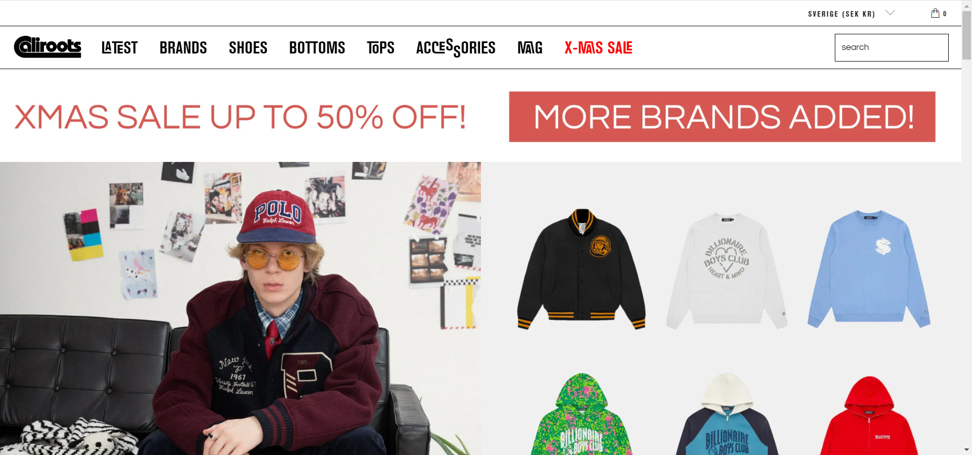

<https://co.rokit.co.uk/?gltm_campaign=hp_r&gltm_source=https://www.rokit.co.uk&gltm_medium=wi_proxy&gltm_content=en_GB&gltm_term=a&gltm___ga=GA1.3.1229293415.1672070830>

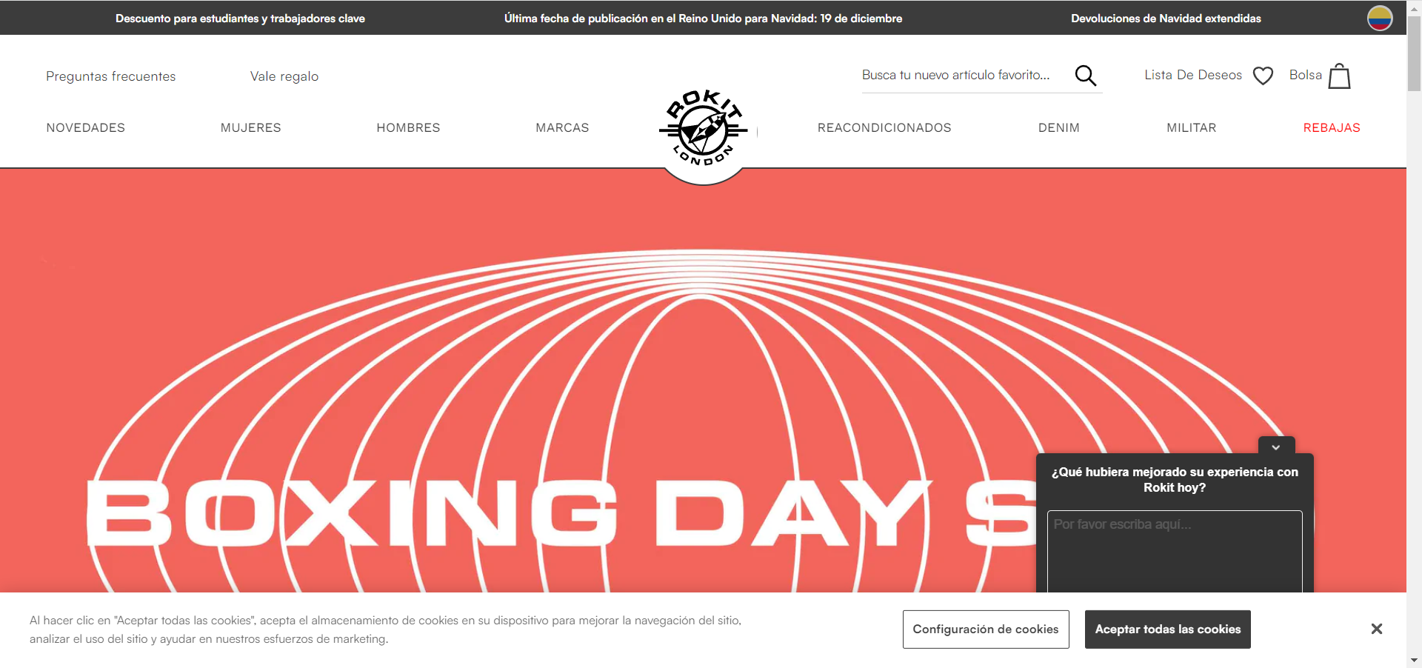

<https://www.loft.com/>

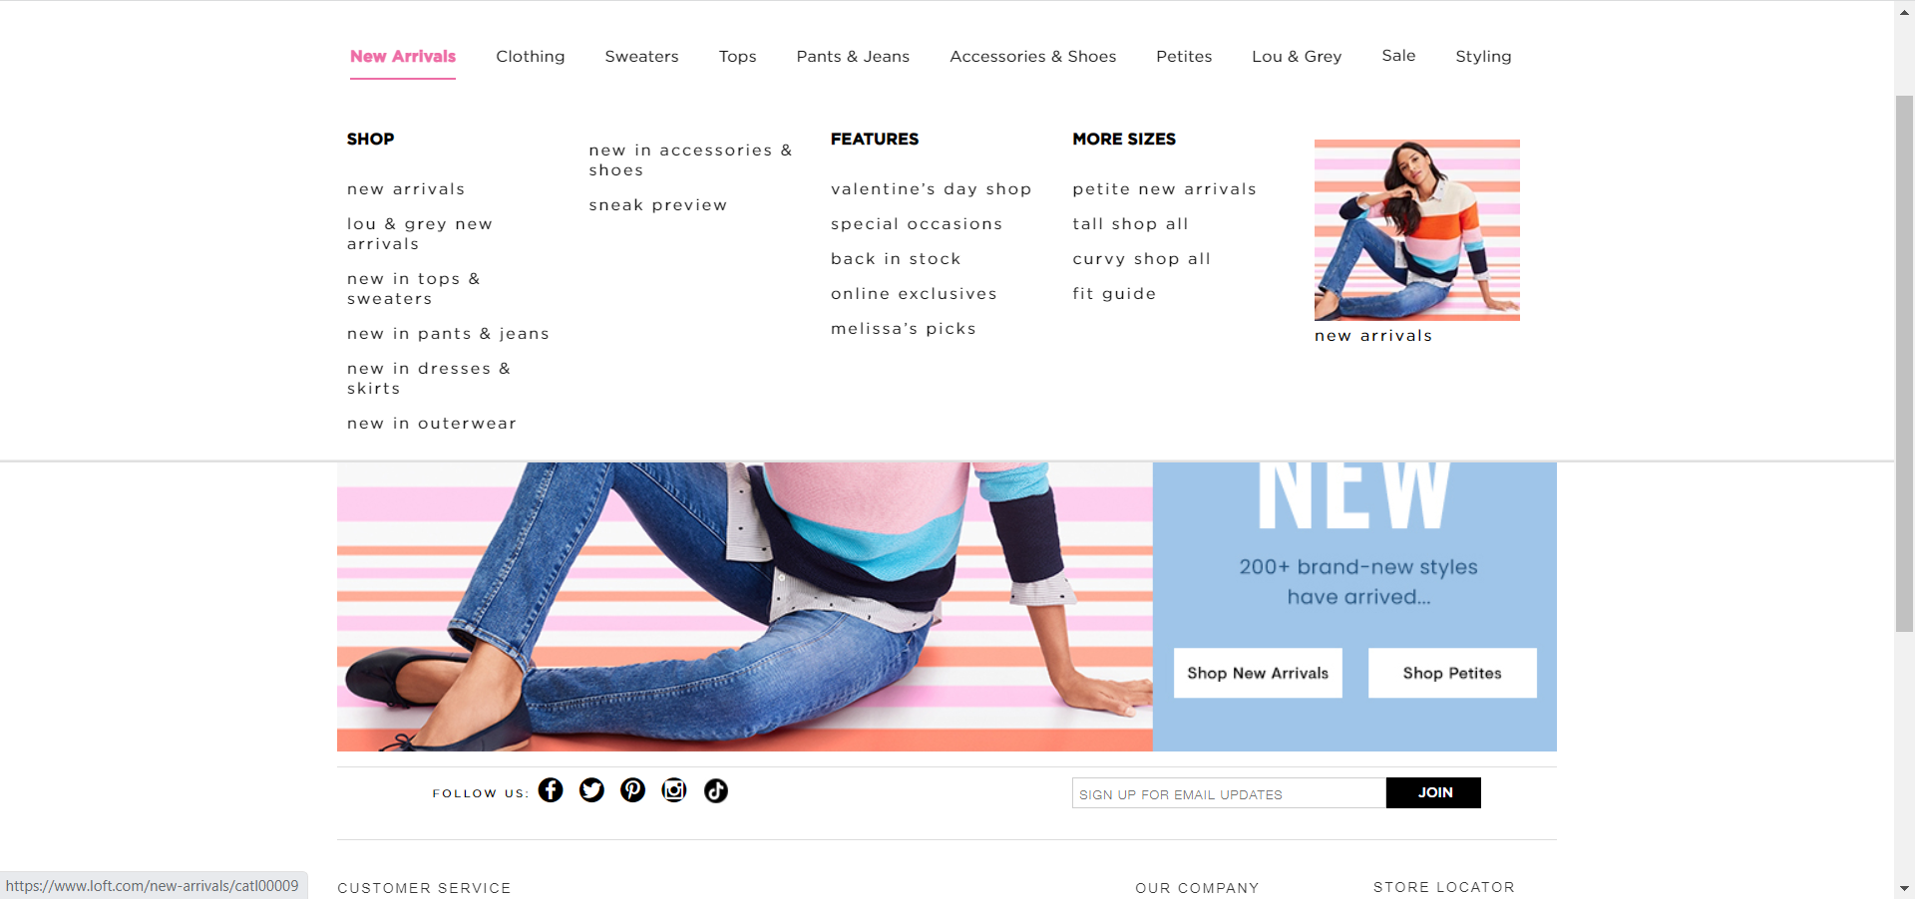

<https://www.mercadona.es/>

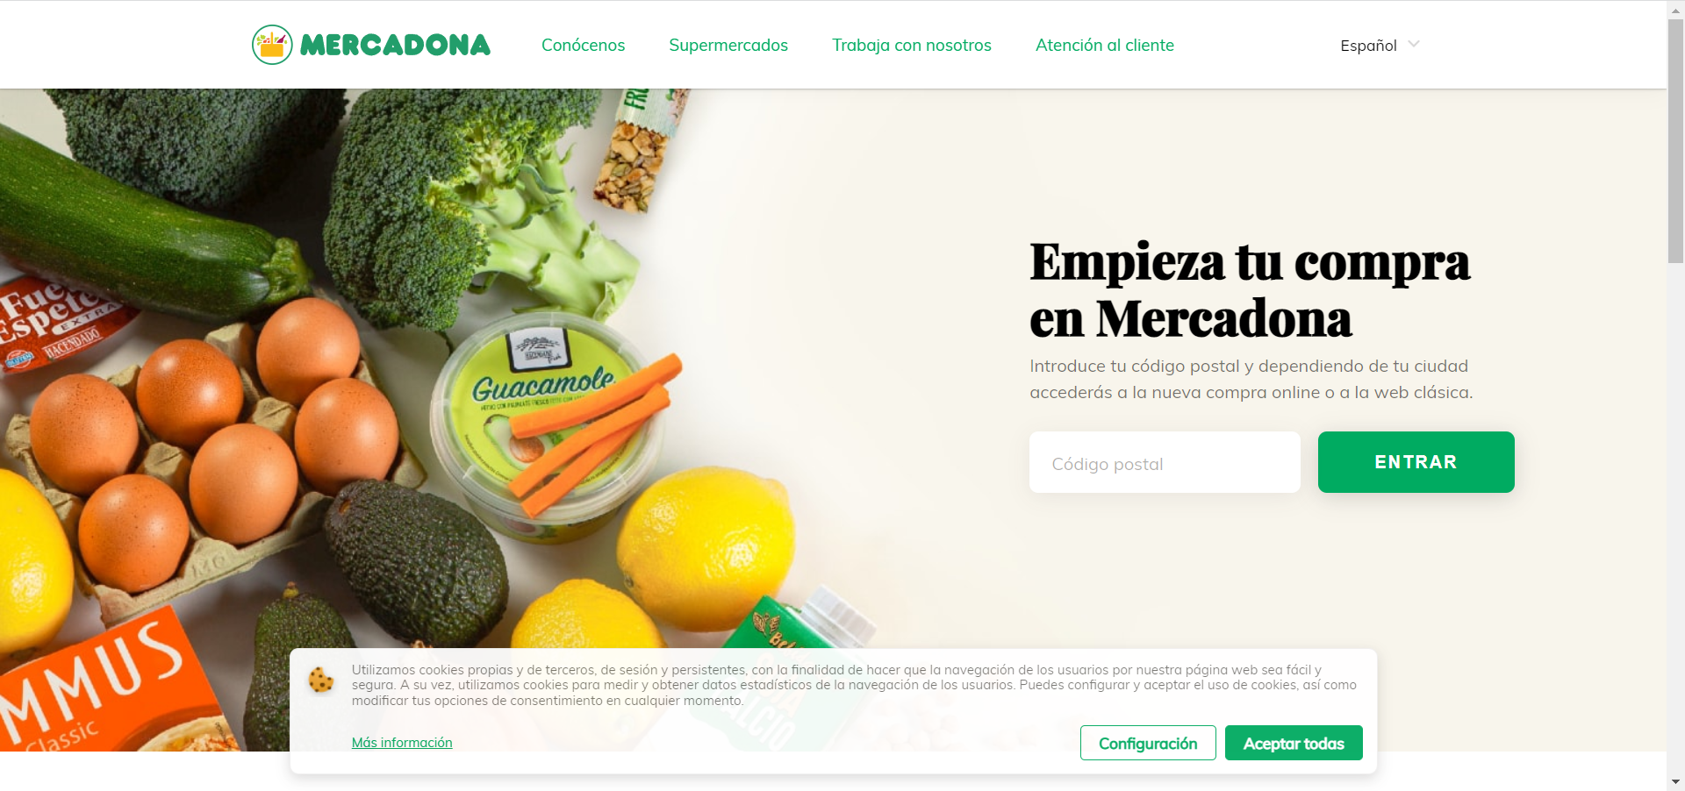

<https://broekhofcolombia.com/?gclid=CjwKCAiAqaWdBhAvEiwAGAQltmo450Tj5CKcvhDeRModo31erAuLZzunM2CN1x5m_xXc5774y9ofuRoCAhIQAvD_BwE>

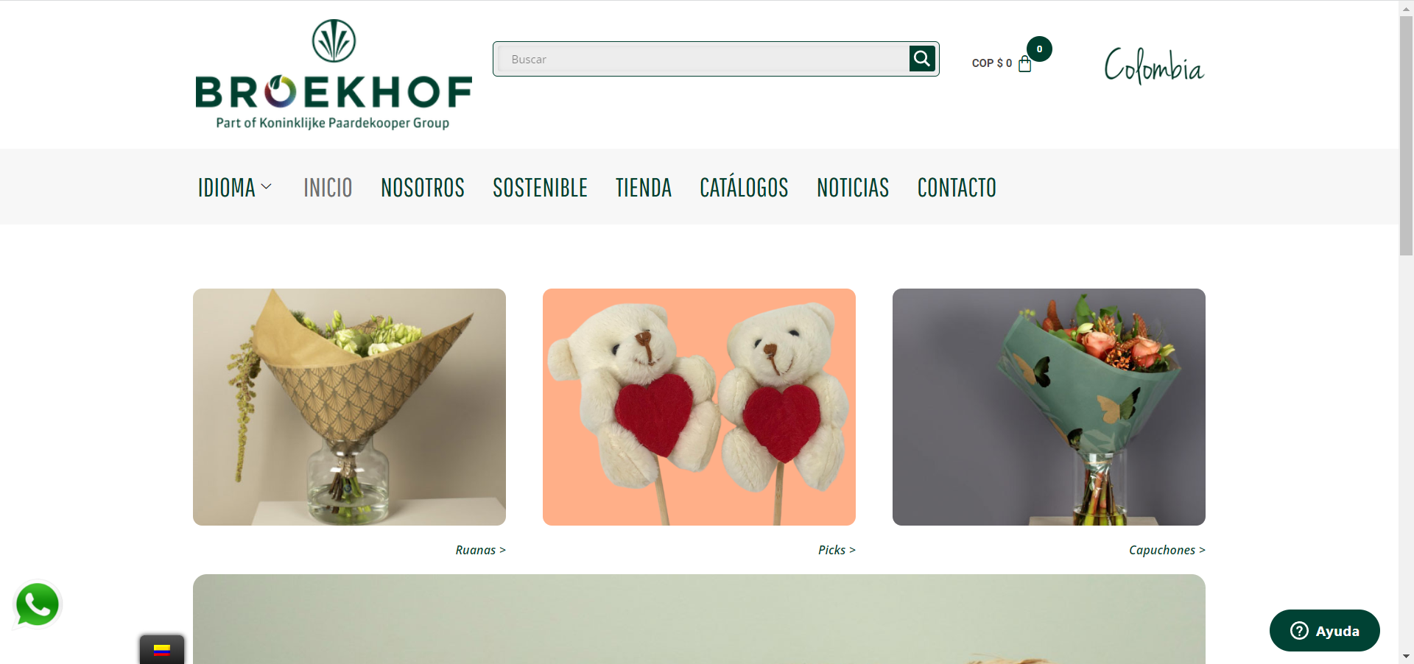

<https://lavishalice.com/en-co/>

